**Practical Robotics Projects with Arduino**

**(CSE 4571)**

**Lab Assignment No – 05**

**Temperature Monitoring**

**Submission Date: _______________**

|  |  |  |
| --- | --- | --- |
| **Branch: CSE Section:** | | |
| **Name** | **Registration No.** | **Signature** |
|  |  |  |

Department of Computer Science and Engineering

Institute of Technical Education and Research (Faculty of Engineering)

**Siksha 'O' Anusandhan (Deemed to be University)**

**Bhubaneswar**

## 

## Aim

**Analog to Digital Converter-**To interface an analog temperature sensor (LM35) and a digital temperature sensor (DHT11) with an Arduino Uno, utilizing the Arduino’s ADC to read and convert the analog output from the LM35 and digital communication protocols to read data from the DHT11, thereby enabling accurate measurement and display of ambient temperature in degrees Celsius.

# Objectives:

1. To set up and connect the LM35 analog temperature sensor to the Arduino, read the analog voltage using the ADC, and convert it into a temperature value in degrees Celsius through the Arduino program.
   1. Understand the working principle of the LM35 temperature sensor, which provides an output voltage proportional to temperature (10 mV/°C).
   2. Interface the LM35 sensor with the Arduino Uno by connecting its output pin to an analog input pin .
   3. Utilize the Arduino’s 10-bit Analog-to-Digital Converter (ADC) to read the analog voltage using the analogRead() command.
   4. Convert the analog reading into temperature in degrees Celsius using the formula:  
       T(°C)=(AnalogValue×5.0×100)/1024
   5. Display the calculated temperature values on the Serial Monitor for observation and verification.
2. To connect the DHT11 digital temperature sensor to the Arduino, interface it via a digital input pin, and write a program to communicate with the sensor and read temperature data.

2.1 Understand the digital communication protocol used by the DHT11 sensor for transmitting temperature and humidity data.

2.2 Connect the DHT11 data pin to a digital input pin of the Arduino Uno.

2.3 Implement the DHT library functions in the Arduino sketch to initialize and read digital temperature data.

2.4 Display the measured temperature values from the DHT11 on the Serial Monitor for comparison and validation.

1. To display temperature readings from both LM35 and DHT11 sensors on the serial monitor or an LCD display.

3.1 Develop an Arduino program capable of acquiring data from both analog (LM35) and digital (DHT11) sensors simultaneously.

3.2 Format the serial output to clearly distinguish between LM35 and DHT11 temperature readings.

3.3 Optionally interface a 16×2 or OLED display to present temperature readings without the need for a computer.

3.4 Ensure accurate and real-time data display for both sensors under varying environmental conditions.

1. To compare temperature measurements from the LM35 and DHT11 sensors and observe any differences.

4.1 Record and analyze temperature data from both sensors under identical environmental conditions.

4.2 Observe variations in readings due to sensor characteristics, calibration, or response time.

4.3 Interpret differences to understand the performance, sensitivity, and accuracy of analog versus digital temperature sensors.

4.4 Conclude the experiment by summarizing the comparative behavior and reliability of both LM35 and DHT11 sensors.

## 

**Pre-Lab Questions**

1. What is the function of the Analog-to-Digital Converter (ADC) in Arduino Uno?
2. What is the range of digital values that the analogRead() function can output in Arduino Uno?
3. What is the voltage range that can be read by the Arduino Uno’s ADC?
4. How is the analog voltage from the LM35 sensor related to temperature in degrees Celsius?
5. Write the formula used to convert the ADC reading from the LM35 sensor into temperature.
6. What type of signal does the DHT11 sensor provide to the Arduino — analog or digital?
7. Which library is used in Arduino to read data from the DHT11 sensor?
8. What parameters can be measured using the DHT11 sensor?
9. Why might temperature readings from the LM35 and DHT11 sensors differ slightly?
10. How can temperature readings from both LM35 and DHT11 be displayed on the Serial Monitor or LCD?

# **Components/Equipment Required:**

|  |  |  |  |
| --- | --- | --- | --- |
| **Sl.**  **No.** | **Name of the**  **Component / Equipment** | **Specification** | **Quantity** |
| **1** | Arduino UNO R3 | 16 MHz | 1 |
| **2** | USB Cable | Type‑A to USB‑B/Micro‑B  (as applicable) | 1 |
| **3** | DHT11 Sensor | 3–5 V, single‑wire digital | 1 |
| **4** | LM35 Sensor | 10 mV/°C analog, −55 to 150°C | 1 |
| **5** | 16×2 I2C LCD | I2C backpack (PCF8574), 5 V | 1 |
| **6** | Breadboard | ≥ 400 tie‑points | 1 |
| **7** | Resistors (for LM35 wiring if needed) | 10 kΩ (pull‑down optional) | 1 |
| **8** | Jumper wires | M‑M / M‑F | As reqd. |
| **9** | External supply (optional) | 5 V regulated | 1 |

**Objective 1**

To set up and connect the LM35 analog temperature sensor to the Arduino, read the analog voltage using the ADC, and convert it into a temperature value in degrees Celsius through the Arduino program.

## Circuit / Schematic Diagram



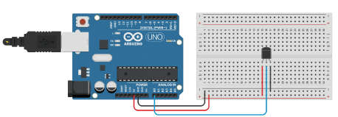

## Code

## Observation

| **S.No.** | **Analog Value (ADC Reading)** | **Calculated Voltage (V)** | **Temperature (°C)** |
| --- | --- | --- | --- |
| 1 |  |  |  |
| 2 |  |  |  |
| 3 |  |  |  |
| 4 |  |  |  |
| 5 |  |  |  |

**Objective 2**

To connect the DHT11 digital temperature sensor to the Arduino, interface it via a digital input pin, and write a program to communicate with the sensor and read temperature data.

## Circuit / Schematic Diagram

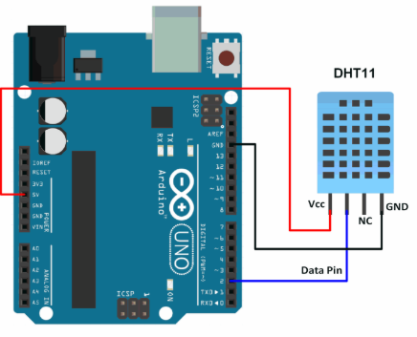

## Code

## Observation

| **S.No.** | **Temperature (°C)** | **Humidity (%)** | **Conditions** |
| --- | --- | --- | --- |
| 1 |  |  | Normal room condition |
| 2 |  |  | Slightly warmer |
| 3 |  |  | Moderate temperature |
| 4 |  |  | Slight cooling |
| 5 |  |  | Warmer environment |

**Objective 3**

To display temperature readings from both LM35 and DHT11 sensors on the serial monitor or an LCD display.

## Circuit / Schematic Diagram

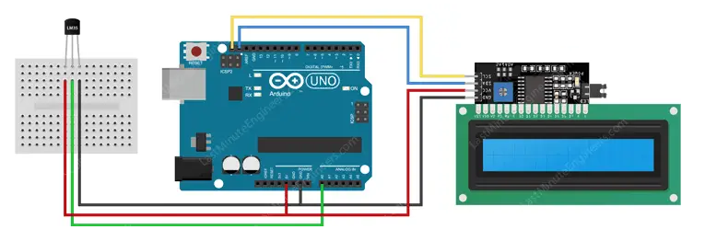

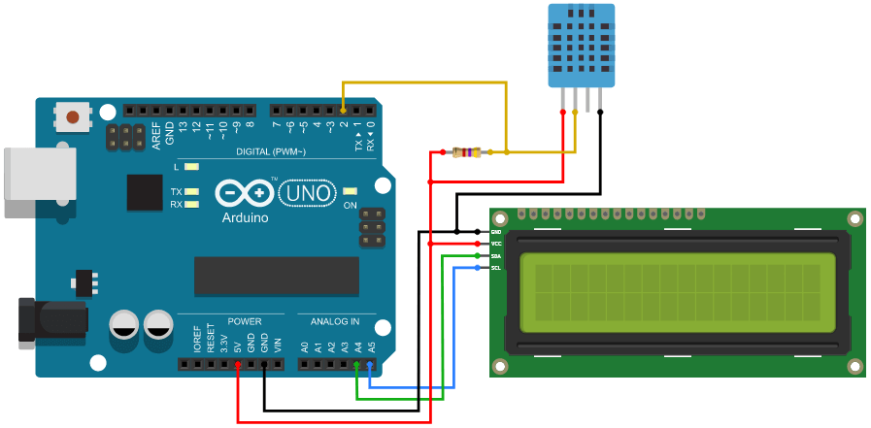

## Code

## Observation

| **S.No.** | **LM35 Temperature (°C)** | **DHT11 Temperature (°C)** | **DHT11 Humidity (%)** | **Remarks / Notes** |
| --- | --- | --- | --- | --- |
| 1 |  |  |  |  |
| 2 |  |  |  |  |
| 3 |  |  |  |  |
| 4 |  |  |  |  |
| 5 |  |  |  |  |

**Objective 4**

To compare temperature measurements from the LM35 and DHT11 sensors and observe any differences.

## Circuit / Schematic Diagram





## Code

## Observation

| **S.No.** | **LM35 Temp (°C)** | **DHT11 Temp (°C)** | **Difference (°C)** | **Remarks** |
| --- | --- | --- | --- | --- |
| 1 |  |  |  |  |
| 2 |  |  |  |  |
| 3 |  |  |  |  |
| 4 |  |  |  |  |
| 5 |  |  |  |  |

**Graph**

**Instructions to Plot:**

* X-axis: **Observation Number (1–5)**
* Y-axis: **Temperature (°C)**
* Plot two lines:
  + **LM35 Temp** (Analog)
  + **DHT11 Temp** (Digital)

| **Observation No** | **LM35 Temp** | **DHT11 Temp** |
| --- | --- | --- |
| 1 |  |  |
| 2 |  |  |
| 3 |  |  |
| 4 |  |  |
| 5 |  |  |

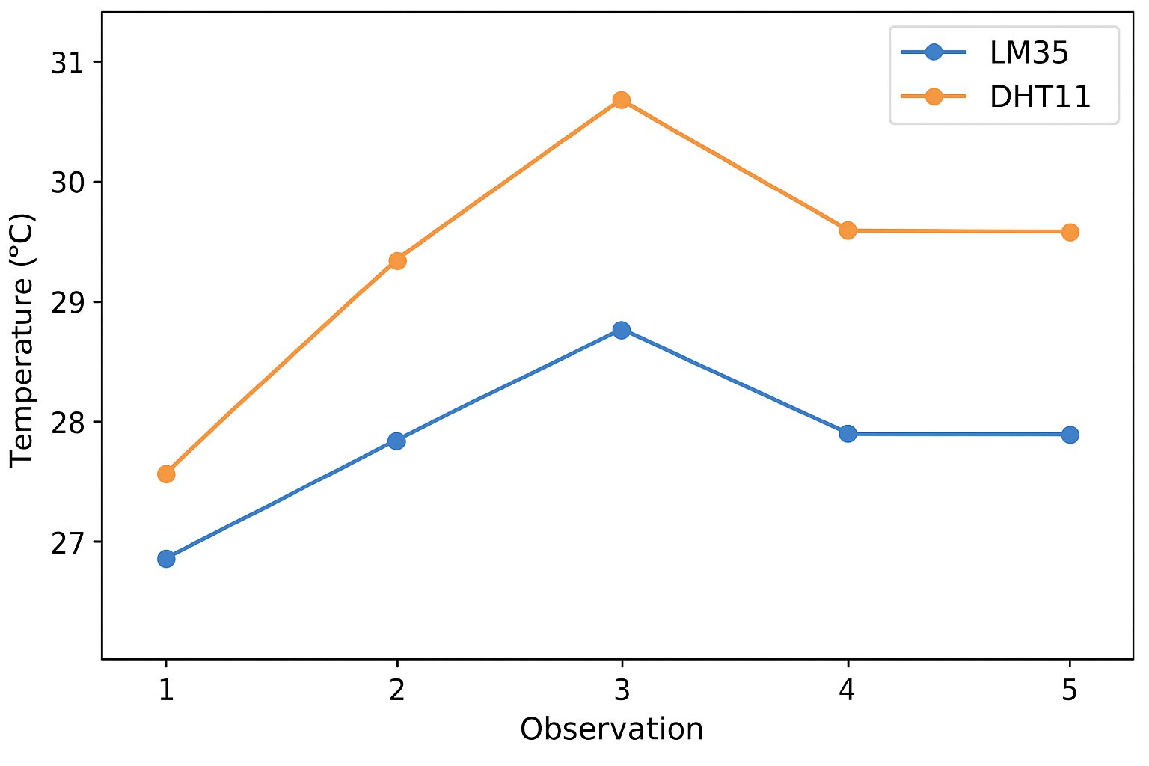

**CONCLUSION:**

**PRECAUTION:**

**Answers to Post-Lab Questions**

1. What is the significance of resolution in an Analog-to-Digital Converter, and how does it affect measurement accuracy in Arduino?
2. How does the reference voltage (Vref) influence the output of the ADC in Arduino Uno?
3. Explain the concept of sampling in ADCs and why sampling rate is important in data acquisition systems.
4. What are the advantages and disadvantages of using analog sensors like LM35 compared to digital sensors like DHT11?
5. How does noise affect analog readings in microcontroller-based systems, and what techniques can be used to reduce it?